SET 10 – SURVEY RESPONSES ANALYSIS
Aim
To analyze survey responses using grouped bar chart, stacked bar chart, and table in R.
Algorithm
- Create the survey response dataset.
- Count the responses for Question 1.
- Create a grouped bar chart for Question 1.
- Create a stacked bar chart for all three questions.
- Display the survey data in a table.
R Program
library(ggplot2)
library(tidyr)

survey <- data.frame(
ID=c(1,2,3),
Question1=c("A","B","C"),
Question2=c("B","A","A"),
Question3=c("C","D","B")
)

long <- pivot_longer(survey, -ID,
names_to="Question", values_to="Answer")

ggplot(long[long$Question=="Question1",],
aes(Answer, fill=Answer)) +
geom_bar() +
labs(title="Question 1 Response Distribution",
x="Answer", y="Count")

ggplot(long, aes(Question, fill=Answer)) +
geom_bar() +
labs(title="Survey Response Distribution",
x="Question", y="Count")

print(survey)
OUTPUT:
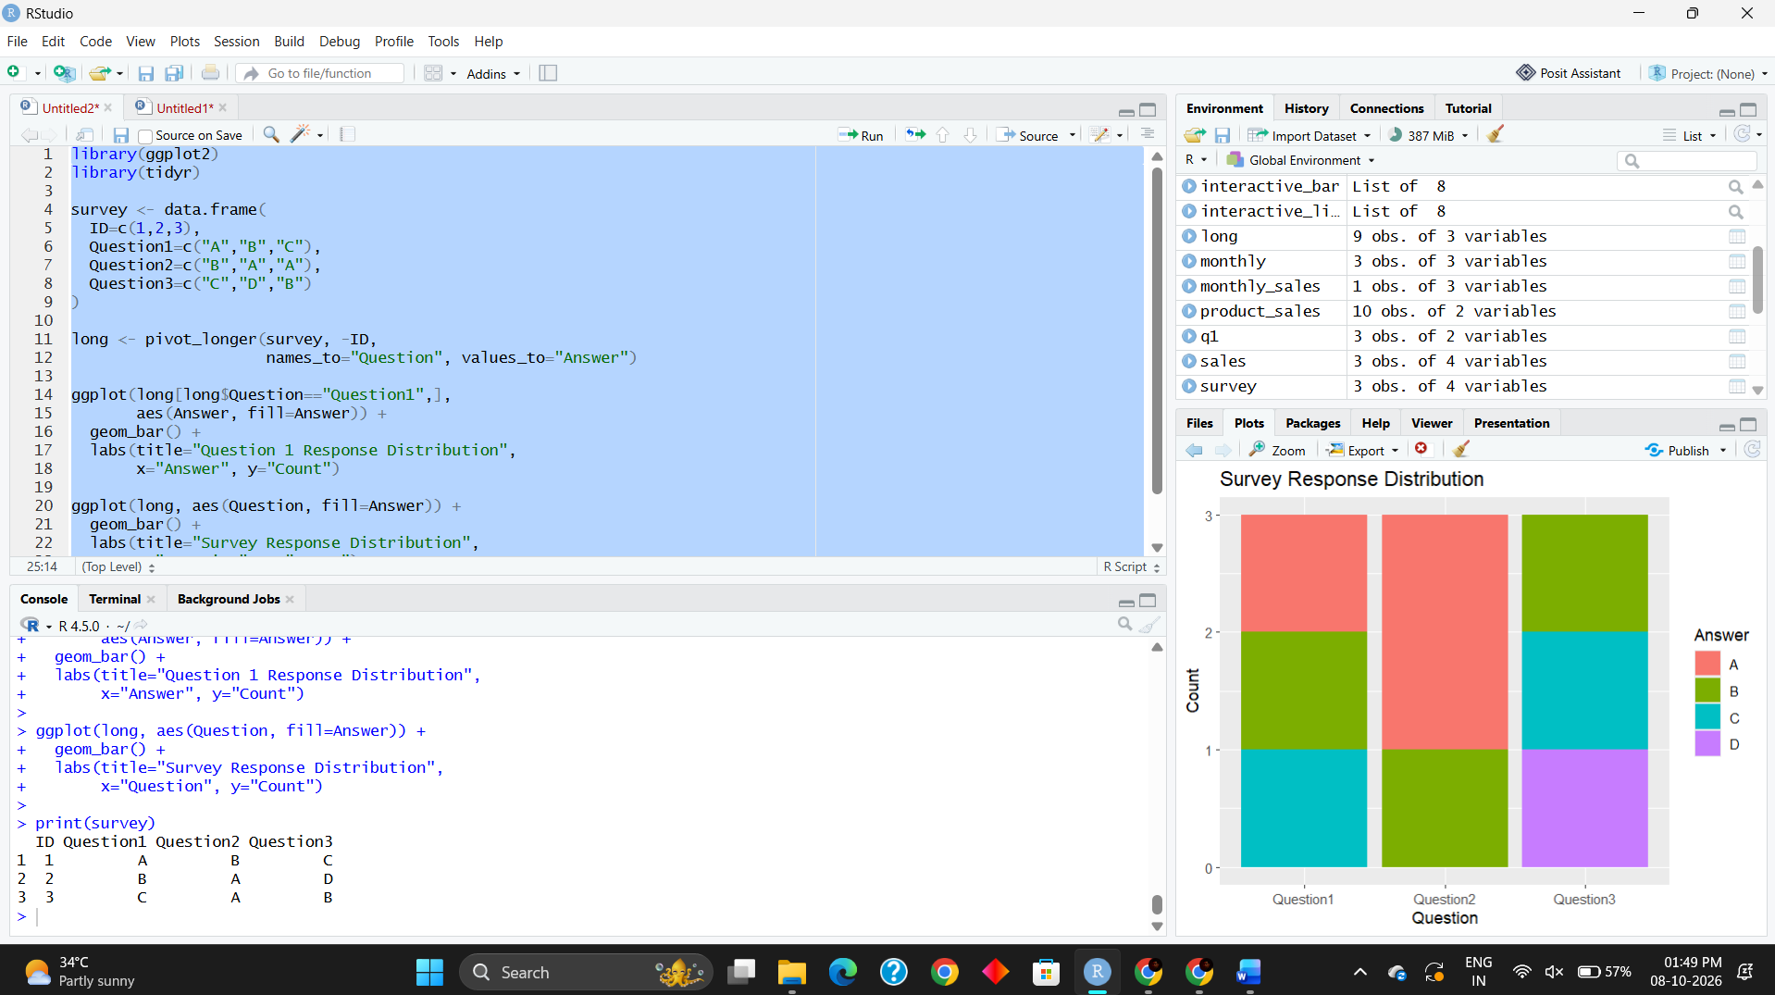
Result
The grouped bar chart displays the distribution of answers for Question 1. The stacked bar chart represents the overall response distribution for all three questions, and the table displays the survey responses.

